THE FITZHENRY FAMILY OF MACMINE CASTLE
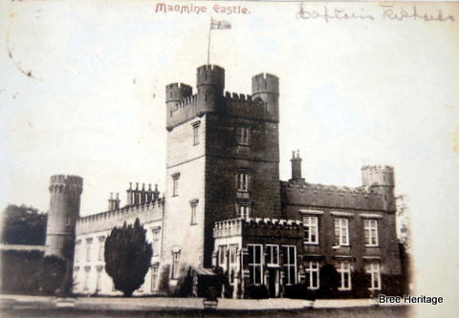
Macmine Castle in c. 1900
During the medieval period the now derelict Macmine castle was home to one of Wexford’s most prominent families, the Fitzhenrys. Originally from the Pembroke region in Wales the Fitzhenrys arrived in Ireland with the first wave of Anglo-Norman colonists in 1169/70 AD. They quickly became established in Wexford and were to play a significant role in the county’s history. The earliest surviving reference to them at Macmine dates to 1296 AD, when John Fitzhenry held the manor of ‘Mawmayne’ from William de Valance, Earl of Pembroke in return for 1 knight’s fee (St. John Brooks 1950, 189). This manor was quite extensive and it appears to have encompassed the modern townlands of Macmine, Kilgibbon, Knockduff, Coolteigue, and Kilray (the last townland no longer exists but originally it was located near Knockduff). The site of the castle probably formed the centre of this manor, while a moated site located in Kilgibbon townland may represent an outlying estate farm. The Fitzhenrys were to remain at Macmine right up until the Cromwellian confiscations of the 1650′s, when their staunch support for the Confederate cause saw them lose everything.
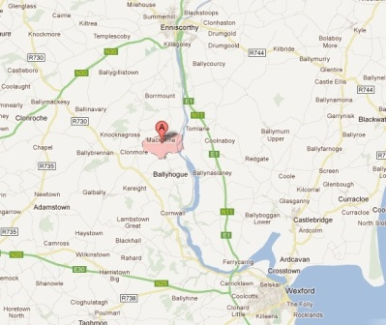Location of Macmine townland (click to enlarge)
The 14th Century
During the fourteenth century the family became firmly ensconced at Macmine, although as a number of incidents indicate, their manor was not wholly secure from attack. In the early 1330’s a feud appears to have developed between the two main branches of the Fitzhenry family, which were located at Macmine and Kilcavan respectively. In the spring of 1332 Mathew Fitzhenry of Macmine and a group of armed men attacked his cousin Stephen Fitzhenry’s castle at Kilcavan (near Wellingtonbridge). They stole a number of items including a mill (for grinding corn), two tables (one of them a chess board), a cooking pot, three tripods, three locks, two chests, and a towel (Hore 1920, 69). Stephen complained to the authorities who ordered Mathew’s arrest and imprisonment. The following year Stephen gained revenge when he attacked Macmine, possibly while Mathew was still in prison. He broke into Mathew’s house and stole a number of charters including Mathew’s father’s deed of enfeoffment, which related ‘to certain tenements in Mackmine and Fornagh’ (St. John Brooks 1950, 189). Mathew was subsequently released from prison after paying a 1 mark fine. Shortly afterwards, in 1335 a Mathew FitzHenry was summoned to fight in Scotland and this may have been Mathew from Macmine (see Butler 1841, 172). The following year Mathew was back in Wexford, when he led a large force of men against the McMurchada and O’Breen clans. This battle went disastrously for the Anglo-Normans, with over 200 men killed including the aforementioned Mathew (Note 1).
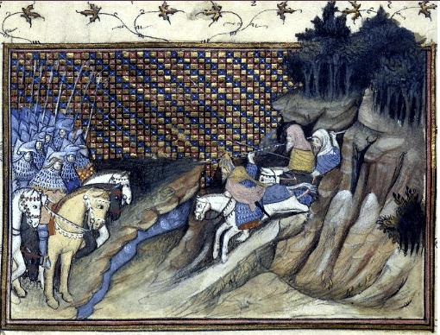14th century encounter between the Irish and Anglo-Normans (after Histoire du roy d’Angleterre Richard II)
In 1356 the Fitzhenrys of Macmine were once more called upon to the defend the colony, when John, probably Mathew’s son, had to provide a force horse and foot soldiers to fight on behalf of the Lords Justice (Griffiths 1877, 364). The final decades of the 14th century also saw a Mathew Fitzhenry take charge of Enniscorthy castle, which is situated roughly 7.5km to the north of Macmine. This was a difficult location to defend as it was virtually surrounded by the Irish and in 1380 Matthew complained that he had lost seven of his men defending the castle (Calendar of Irish Chancery Letters). Enniscorthy’s proximity to Macmine may indicate that this Mathew Fitzhenry was member of the Bree branch of the family rather than Kilcavan branch, which is situated in the far south of the county (c. 27km from Enniscorthy).
The 15th century
Although the fifteenth century activities of the Fitzhenrys are less well documented, it is recorded that John Fitzhenry of Macmine attained the highest rank in the Knights Hospitallers, when he became Head Prior in 1419. The Hospitaller’s were a religious order of knights whose origins lay in the holy land where they protected pilgrims and fought the Saracens (Muslims). In Ireland they were entrusted with defending the English colony and one of their main preceptories (monasteries) was actually located in Ballyhogue
The fifteenth century may have also been the period when the oldest parts of the surviving castle at Macmine were built (Click here for more detailed information). The present ruins at Macmine consist of a medieval tower house (WX032-001) that was much modified in the nineteenth century when two additional wings were added. The medieval tower survives to a least the third storey and measures circa 7.65m east-west by 7.5m north-south. Towers houses, such as Macmine are generally accepted to date from the 15th and 16th centuries AD. The impetus for their construction appears to have been a subsidy issued in 1429 which granted £10 to anyone who built a castle or tower within the Dublin Pale. In 1441 this policy was extended to Co. Wexford when an Act of Parliament was passed for ‘building towers upon the waters or river of Taghmon in county Wexford’ (Colfer 2002, 241). It is possible that Macmine castle, with its commanding views over the River Slaney, was also constructed at this time.
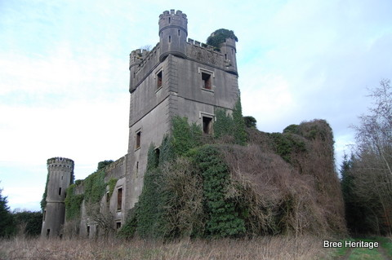Macmine Castle today
16th century
The surviving documents suggest that the sixteenth century was an eventful period for the Fitzhenry family. It saw them change their name to Fitzharris as well as significantly increase the extent of their lands within the parish. Their enlarged estate now included the townlands of Ballybrennan, Tomfarney, Raheenahoun and Carriginaine, all of which had formerly been part of the Keating manor of Kilcowanmore (a medieval parish based around Ballybrennan church).
That tension existed over the extent of the Fitzharris/Fitzhenry possessions is indicated by a document dating from 1558 (see Haliday 1897, 76-78). This describes a land dispute between Richard Butler, Lord Mountgarrett, of Kayer (Wilton castle) and Thomas Fitzhenry and his son Mathew of Maghmaine (Macmine). The disagreement was settled by the Lord Justice who decreed that Richard Butler should get the townlands of ‘Prishhagard’ (this location is uncertain) and ‘Ballewarkley’ (Ballybuckley), while Thomas Fitzhenry would receive ‘Kilherie’ (Kilray) and Kilgibbone (Kilgibbon). Sir Henry Radcliffe and the Sheriff of Carlow, Captain Herne, were to oversee the re-defining of these properties and both protagonists were to sign and seal a map which would outline the agreed extents of their lands.
By the late 1560’s Thomas Fitzhenry’s son Mathew appears to have inherited his estate. During this period Mathew was sub-seneschal for Wexford, although this did not stop him falling out with the Dublin authorities. For instance in November 1569 he was pardoned, probably for participating in the Butler rebellion of that same year. A number of other Bree men are also mentioned in this pardon including ‘Arthur Fitzharris of Maghmayn (Macmine), John Roche of Gibbons wood (Kilgibbon), Nicholas Fitz Henry of Killery (Kilray) and Edmund O’Doyle of Maghmayn’ (Ferguson 1881). The Butler rebellion was led by Edmond Butler of Cloghgrennan, Kilkenny and it saw much fighting in Co. Wexford, where some of the local lords joined his cause. The zenith of the Wexford fighting was the sacking of Enniscorthy, which occurred on the 14th of August 1569. This was the town’s annual fair day and a huge crowd had gathered there. The assault on the town appears have been bloody with a contemporary account describing it thus ‘The said spoil was very great, besides the killing and drowning of many people, and many prisoners taken, and specially divers of the good women of Wexford.” (Calendar of Cecil Papers)
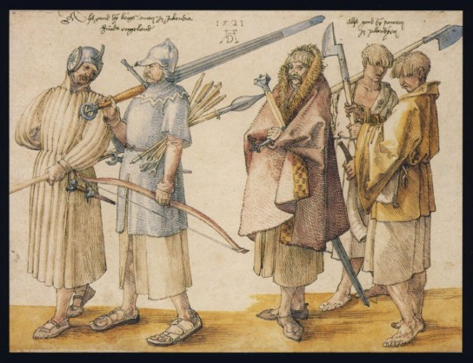
Not long afterwards in 1572 Mathew Fitzharris of ‘Magsmagh’ (Macmine) was once more in trouble with the authorities (Hogan 1878, 60). On the 6thof May of that year a group of men including, amongst others, Mathew Fitzharris, two Furlong bothers from Horetown and the famous Gaelic warlord Feagh McHugh O’Byrne, attacked Mulrankin Castle and murdered its owner Robert Brown. Unsurprisingly Robert’s father in law, Nicholas White, who was also Seneschal of Wexford, demanded justice. When he received news of the killing White was actually attending Elizabeth I’s court in England and the Queen herself got involved in the dispute. She personally signed a letter demanding that the perpetrators be arrested and advised White to ‘to look to the safety of the poor young gentlewoman (Browne’s wife) and her children’ (Brown & Whelan 1987, 469). On returning to Ireland, White and his ally Nicholas Devereux of Balymagir immediately set about attacking the lands of the accused. However, Feagh McHugh was an experienced warrior and he quickly organised an alliance with the Furlongs of Horetown (and probably also the Fitzharrises). With a combined force of over 400 men they defeated an army commanded by White and then attacked Nicholas Devereux’s lands, burning nine towns (including Adamstown) and killing 30 of the local gentry (Byrne-Rothwell 2010, 96).
The perceived treachery of this alliance between the Gaelic Irish O’Byrne’s and the Old English Furlong’s earned the latter the epithet of ‘False Furlongs’. Similarly in c. 1575 the Fitzharrises were described as ‘malefactors, allied with the Cavanaghs’ (Brewer & Bullen 1870, 448). There was further trouble in 1578 when Lawrence Fitzharris (probably Mathew’s son) and an Irish man by the name Donough McTeige were pardoned for breaking the law (Ferguson 1885, 93). Both men were from Mamayne (Macmine) and although the exact offences they committed are not mentioned this incident does illustrate the close links that existed between the Fitzharris family and the Gaelic Irish.
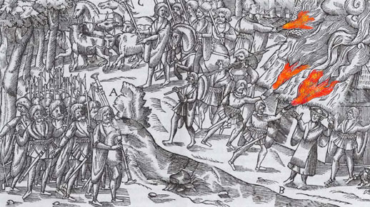Contemporary depiction of a 16th century Irish raid (John Derricke 1581)
Just two years later, however, things were to change drastically, when the Fitzharrises themselves were attacked by their erstwhile allies, the Kavanaghs. On the 1st of April 1580 Feagh McHugh O’Byrne’s cousins the Arte Boy Kavananghs raided Mathew Fitzharris’s lands and tenants. They stole and pillaged as they went taking large quantities of livestock, stored grain and goods. This raid and the subsequent reprisals had far reaching consequences, more of which can read about here. Thus it appears that the Fitzharris alliance with the Gaelic Irish had come to end and in 1586 they are once more described as of ‘English race and blood’ (Griffiths 1890, 22).
During this period some of their estate at Macmine was also sub-let to new tenants. For example in 1581/82 Lodowicke Bryskett, who had been the Queen’s Clerk in Munster and also a noted Elizabethan poet, was granted a farm of c. 120 acres in Maghmaine (Macmine). He appears to have been very satisfied with the locality describing it as ‘very pleasant and the soil very fertile’, although his request for a retinue of ‘eight horsemen and a dozen footemen’ does indicate that he felt the location was susceptible to attack (more on the Brysketts can be read here).
The 17th century
The dawn of the seventeenth century saw the Fitzharrises of Macmine presiding over a large and prosperous manor. The owner of the estate appears to have been Laurence Fitzharris, who in the year of 1600 was pardoned, along with his son Nicholas, for infractions against the crown (Ferguson 1885, 138). By 1640 a survey of Wexford landowners indicates that Macmine had passed into the possession of Mathew Fitzharris, who had recently deceased. He was survived by his wife Anastacia and his young son Nicholas (Hetherington, R. 1827, 147). Mathew was described as the Lord of Macmine, including its village and lands, but little further detail is give. The Civil Survey of 1656 (but which recorded land ownership in 1640-41) is more descriptive. It states that the Fitzharris holdings at Macmine were worth £100 and comprised of 420 acres of land that contained a ‘faire castle’ (Simington 1953, 103). There was also a fish weir on the River Slaney and a corn mill along the Clonmore stream. At Kilcowanmore (Ballybrennan) they owned a fish weir on the River Boro as well as 1000 acres of land (ibid, 219). Surprisingly The Civil Survey indicates that in 1640 the Macmine estate was under the stewardship of Thomas Fitzharris of Kilcavan. Thomas was a cousin of Mathew Fitzharris of Macmine and it appears that he was entrusted with Mathew’s estate until his son and heir Nicholas came of age (Mathew was deceased).
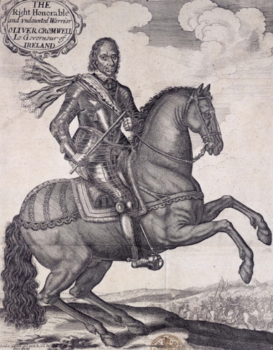Oliver Cromwell
Mathew’s son Nicholas ‘Og’ was an active participant in the Confederate wars of the 1640’s and is named in a number of attacks. For example on the 2nd of March 1641 Nicholas and a party of armed men raided his neighbour, Edward Harris’s farm at Kilgibbon (1641 Depositions). They proceed to steal Edward’s cows and horses, the corn and hay stored in his haggard (farm yard), as well as his pigs, poultry and somewhat unusually ‘four swarms of bees’ (probably bee hives). In addition they robbed a large stockpile of ‘ship planks and timbers’ that Edward had stored, probably with the intention of shipping them down the Slaney for future sale at Wexford. Despite initial successes Nicholas’s Confederate cause suffered a disastrous blow in 1649 when a large Parliamentarian army under the command of Oliver Cromwell landed near Drogheda. Cromwell’s march through Ireland is well documented and his capture of Wexford town and the ensuing massacre is still notorious.
However, the fall of Wexford did not signal the end of the resistance to his rule in the county. In 1650, at the Battle of Lambstown, Glynn, Nicholas Fitzharris and his three brothers made a final stand against Cromwell’s men (Griffiths 1877, 133). They formed part of a local militia, with Nicholas himself in charge of a force of Bantry men. Arranged against them was Cromwell’s battle hardened garrison from Wexford town under the leadership of Henry Ireton. From the start the encounter did not go well for the Wexford men and at a spot still known as ‘Bloody Gap’, the Confederates were defeated. Reputedly the carnage was so great that the surrounding ditches ran red with blood for two days afterwards. The four Fitzharris brothers distinguished themselves during the battle causing much confusion and destruction in the Cromwellian ranks (ibid, 134). By the end of the fighting, however, three were dead, while the fourth was forced to flee, eventually reaching the safety of France. This battle signalled the end of the Fitzhenrys/Fitzharrises at Macmine, after 400 years one of Bree’s oldest and most powerful families was no more. Now all that remains of their once extensive manor are the eerie ruins of Macmine castle.
References
Browne, B. & Whelan, K. 1987 ‘The Browne families of County Wexford’ in Whelan, K. (ed.) Wexford History and Society. Geography Publications, Dublin.
Butler R. (ed.) 1841. Annales Hiberniae, by James Grace. Dublin
Byrne Rothwell, D. 2010. The Byrnes and The O’Byrnes. Argyll
Brewer, J.S. & Bullen, W. (eds) 1870. Calender of Carew Manuscripts 1601-1603. London
Colfer, B. 2002. Arrogant Trespass, Anglo-Norman Wexford 1169-1400. Enniscorthy
Ferguson, S. 1881. The Thirteenth Report of the Deputy Keeper of the Public Records in Ireland. Dublin
Ferguson, S. 1885. The Seventeenth Report of the Deputy Keeper of the Public Records in Ireland. Dublin
Halliday, C. 1897. The manuscripts of Charles Halliday, Esq., of Dublin. Acts of the Privy Council in Ireland, 1556-1571. London
Hetherington, R. 1827. Inquisition Officio Rotulorum Cancellariae Hiberniae Asservatarum Repertorium, Vo. I. Dublin
Hore, P.H. 1920. ‘The barony of Forth: Part 1’ in The Past: The Organ of the Uí Cinsealaigh Historical Society, No. 1.
Griffiths, G. 1877. Chronicles of the County Wexford. Enniscorthy
Simington, R. C. The Civil Survey 1654-1656 Vol. IX County Wexford. Dublin
St. John Brooks, E. 1950. Knights’ fees in counties Wexford, Carlow and Kilkenny. Dublin
Internet resources
Calendar of Cecil Papers: URL: http://www.british-history.ac.uk/report.aspx?compid=111990 . Date accessed: 13 February 2012.
Calendar of Irish Chancery Letters: URL: http://www.irishchancery.net/item.php?item=2352&freetext= . Date accessed: 13 February 2012.
1641 Depositions: URL: http://1641.tcd.ie/deposition.php?depID=818064r090 . Date accessed: 13 February 2012.

